on-line ordering portal

USER MANUAL

**Welcome to the On-line Ordering Portal Training Manual**

The purpose of this training manual is to provide easy step by step instructions on how to navigate through the ordering portal.

The manual will demonstrate step by step instructions for each category on the portal

TERMINOLOGY

**TABLE OF CONTENTS**

1. **Lesson 1 – page**
2. **Lesson 2 – page**
3. **Lesson 3 – page**
4. **Lesson 4 – page**
5. **Lesson 5 – paGE**
6. **lesson 6 – PAGE**
7. **lesson 7 – PAGE**
8. **lesson 8 - PAGE**

**LessoN 1: Accessing the portal**

To access the portal, the Administrator will create your username and password. Once created an email will be sent to you that will include the link or web site address, your user name and password. KEEP IN MIND THAT THE USERNAME AND PASSWORD ARE CASE SENSETIVE

Once you receive the email click on the link and enter in the username and password provided to you. You will be prompted to change your password.

Be sure to bookmark the web address for quick easy access. <http://172.20.29.68:8080/mycart/>

**Lesson 2: Home Page**

**WHen you log in your screen should look like the below (image will need ot be cahnged once portal is completed)**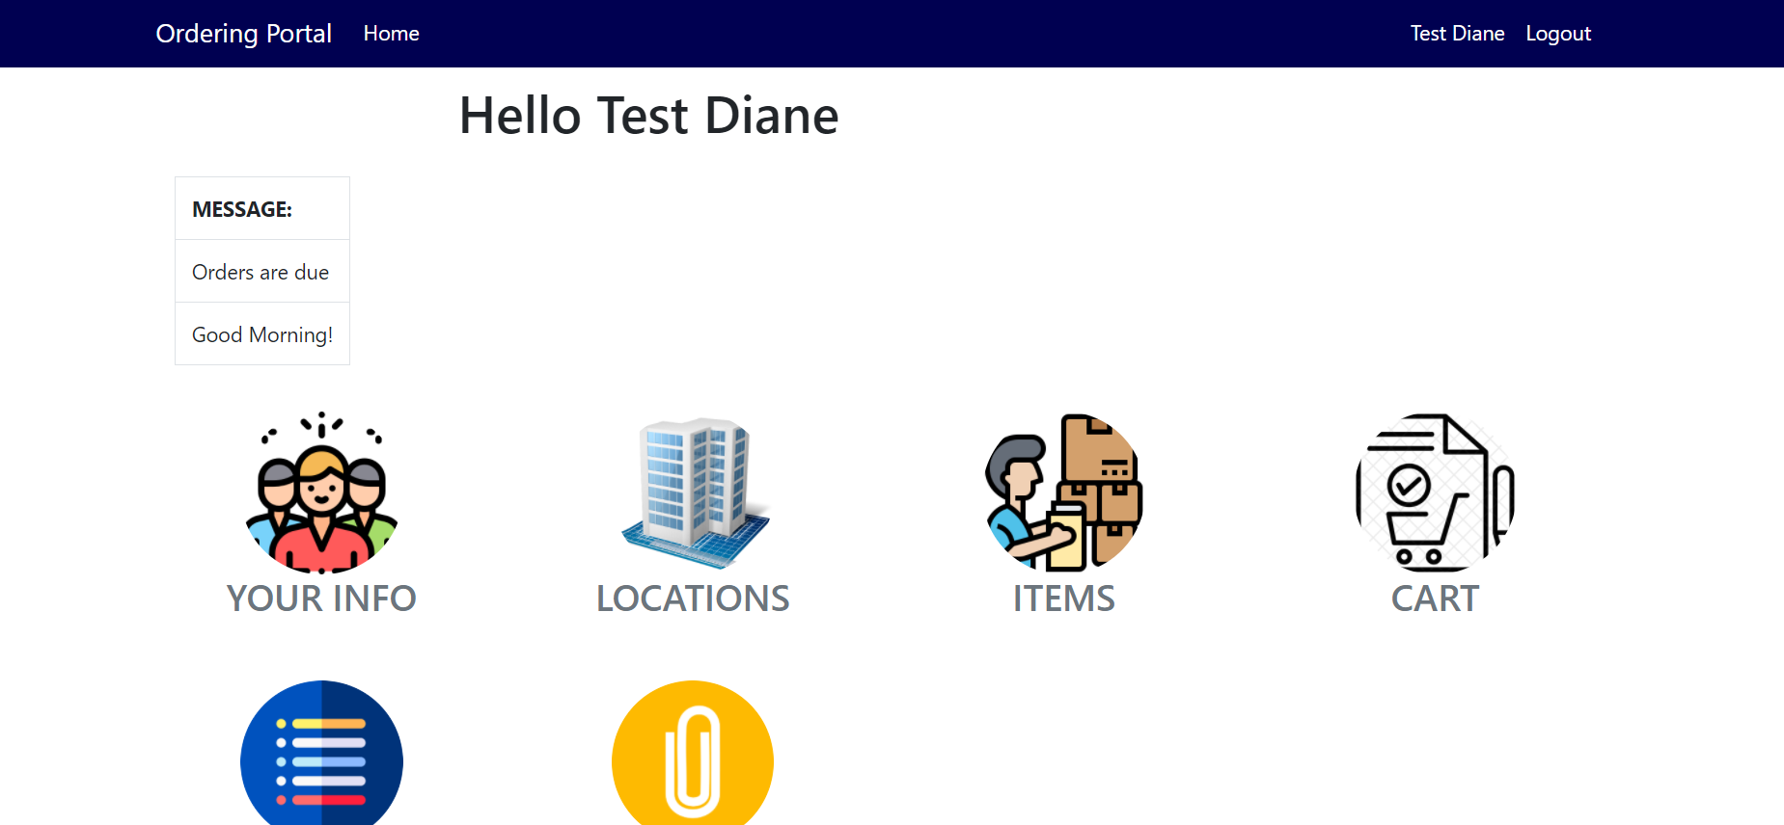

You should see the **Message Board across the top of the home page and the following Icons:**

 **PROFILE**

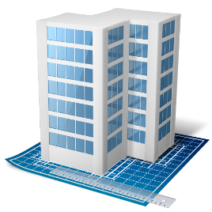**LOCATIONS**

**ORDER HISTORY**

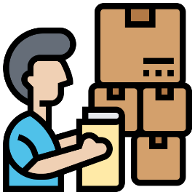 **INVENTORY ITEMS**

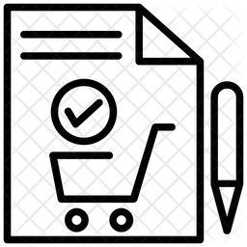 **CART**

**WAITNG APPROVAL**



**(image will need ot be cahnged once portal is completed)**

**Lesson 2: MESSAGE BOARD**

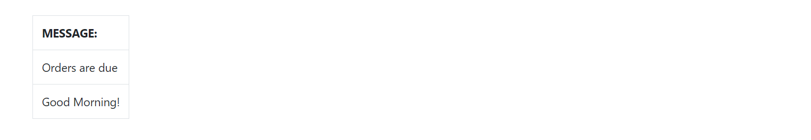

**THE MESSAGE BOARD WILL APPEAR AS A BANNER AT THE TOP OF THE HOME PAGE AND IS USED TO PROVIDE IMPORTANT INFORMATIONS SUCH AS ORDERDUE DATES, ITEM INFORMATION OR SIMPLY A MESSAGE OF GOOD CHEER!**



**Lesson 3: profile**

The PROFILE PAGE INCLUDES THE BASIC INFORMATION ABOUT YOU.

THE ONLY OPTION YOU HAVE ON THIS PAGE IS TO CHANGE YOUR PASSWORD. SHOULD YOU NEED TO DO THIS, FOLLOW THE INSTUCTIONS LISTED BELOW.

cLICK IN THE BOX UNDER PASSWORD, and begin typing your new password (you will be able to see the change as you are typing) **(image will need ot be cahnged once portal is completed)**

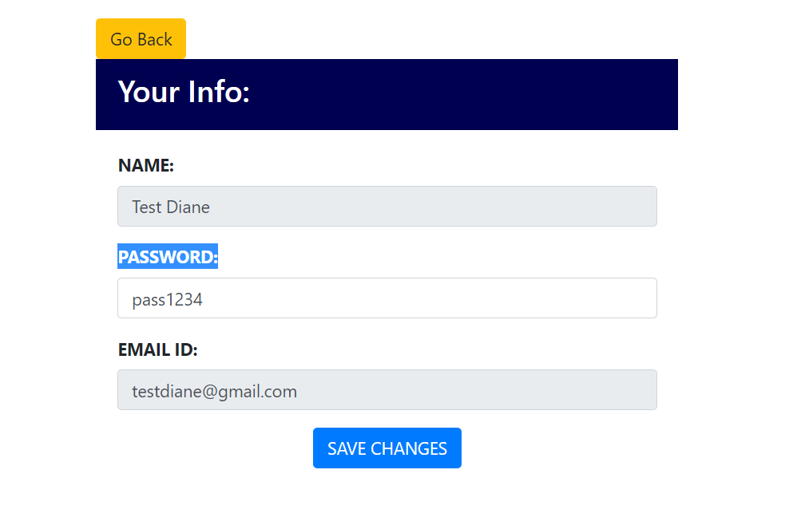

click the Save change buytton at the bottom of the screen

**If you click the back button it will take you back to the home page (image will need ot be cahnged once portal is completed)**



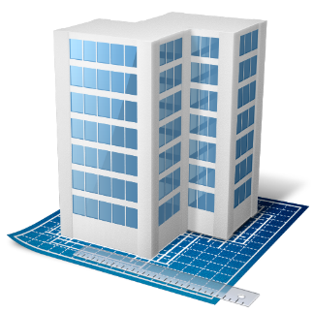

**Lesson 4: LOCATIONS**



**Lesson 5: INVENTORY ITEMS**



**Lesson 6: CART**



**Lesson 7: WAITING APPROVEL**



**Lesson 8: ORDER HISTORY**